**Project Report Template**

**TITLE: JOB APPLICATION TRACKING SYSTEM**

**1. INTRODUCTION**

* 1. **Overview**

Create a CRM Application which helps the applicant to track the No. Of Jobs he applied and helps him to find the job posted by the various recruiters, find the best attributes to be involved to run the process in a smooth way and easily to track.

* 1. **Purpose**
* An ATS allows recruiters to match Job requisitions to the job – posting sites and the social media channels most appropriate for specific candidates.
* An also maximizes visibility for internal job boards.
* While requiring fewer clicks and eliminating barriers for prospective employers.

**2. Problem Definition & Design Thinking**

**2.1 Empathy Map**

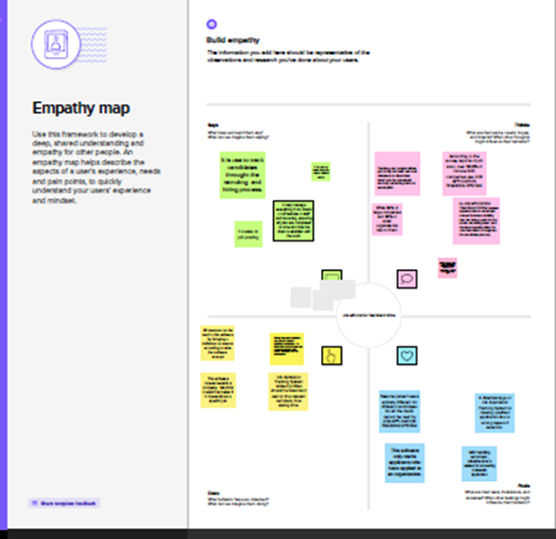

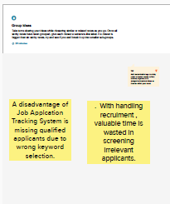**2.2 Ideation & Brainstorming Map**

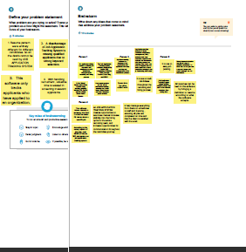

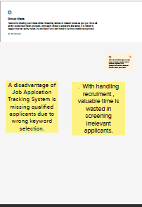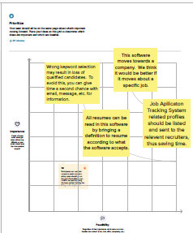

**3. RESULT**

**3.1 Data Model:**

|  |  |
| --- | --- |
| **Object Name** | **Field in the Object** |
| **Obj - 1**  Standard Objects | |  |  | | --- | --- | | Field Label | Data Type | | Recruiter | text | | Recruiters" | text | |
| **Obj - 2**  Custom Objects | |  |  | | --- | --- | | Field Label | Data Type | | Recruiter Number | text | | Auto Number | text | |

**3.2 Activity & Screenshot**

**Activity1:**

**Creating a Salesforce Developer Org:**

A Developer org has all the features and licenses you need to get started with Salesforce.

1. Search Developer.salesforce.com

2. Enter the following details like First name, last name, Email, Role, Company, Country/Region, Postal code, and Username must be unique.

3. Click sign me up, after a few min you will reserve a mail salesforce org and by using the verify account link you can create your new password

.

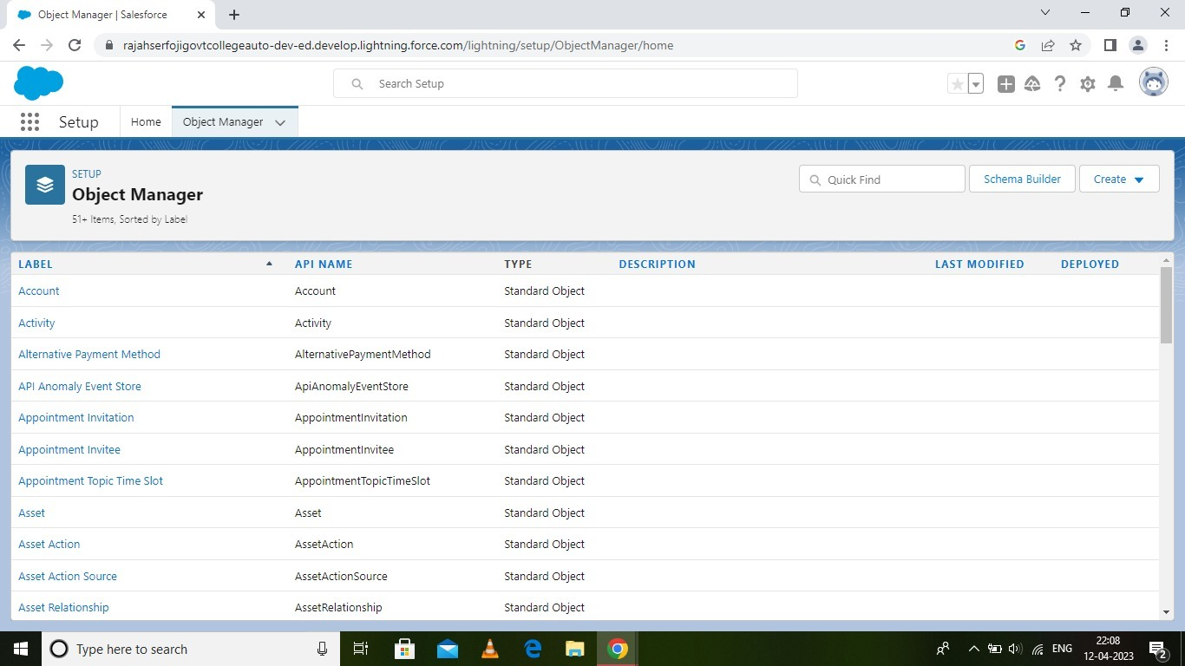

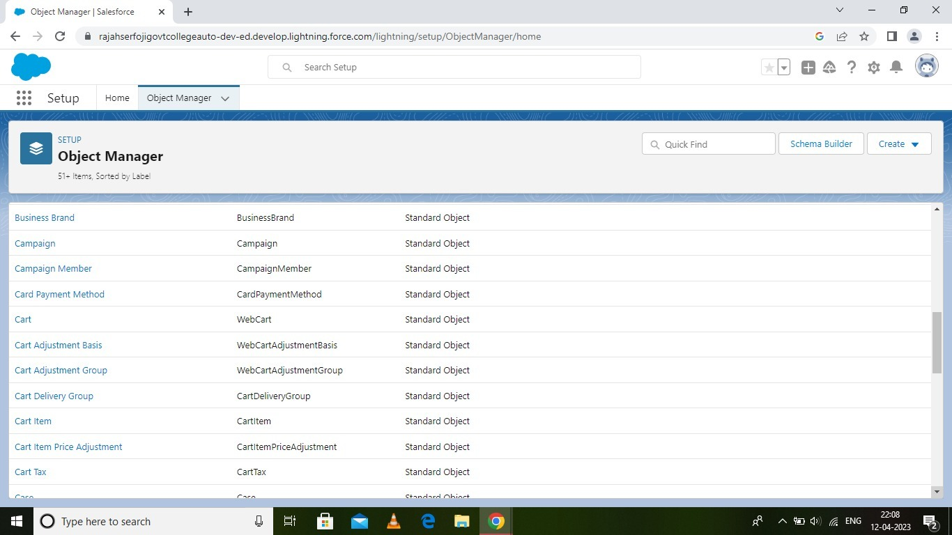

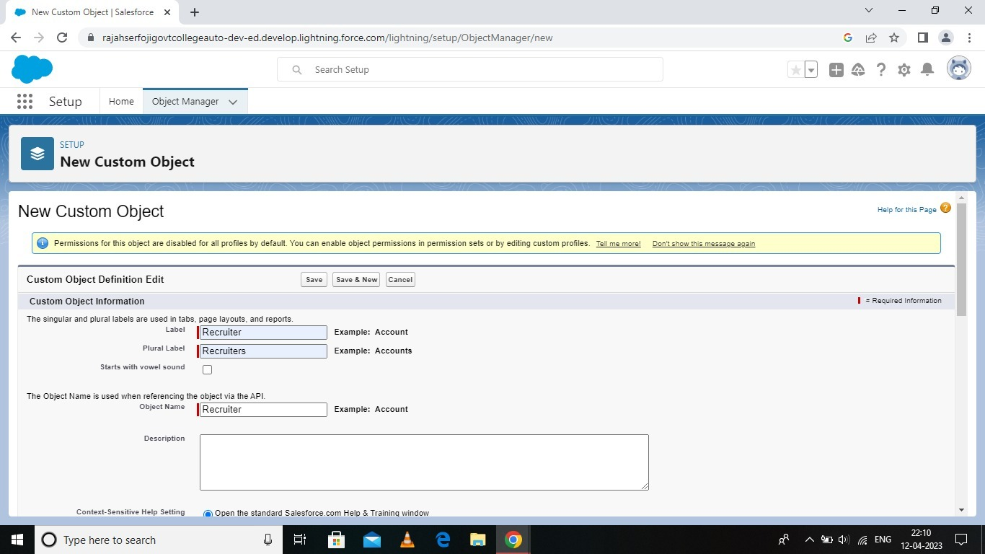

Milestone 2-Object:

What is an object?

Salesforce objects are database tables that permit you to store data that is specific to an organization. It consists of fields (columns) and records (rows).

Salesforce objects are of two types:

● Standard Objects: Standard objects are the kind of objects that are provided by

salesforce.com such as users, contracts, reports, dashboards, etc.

● Custom Objects: Custom objects are those objects that are created by users. They supply information that is unique and essential to their organization. They are the heart of any application and provide a structure for sharing data.

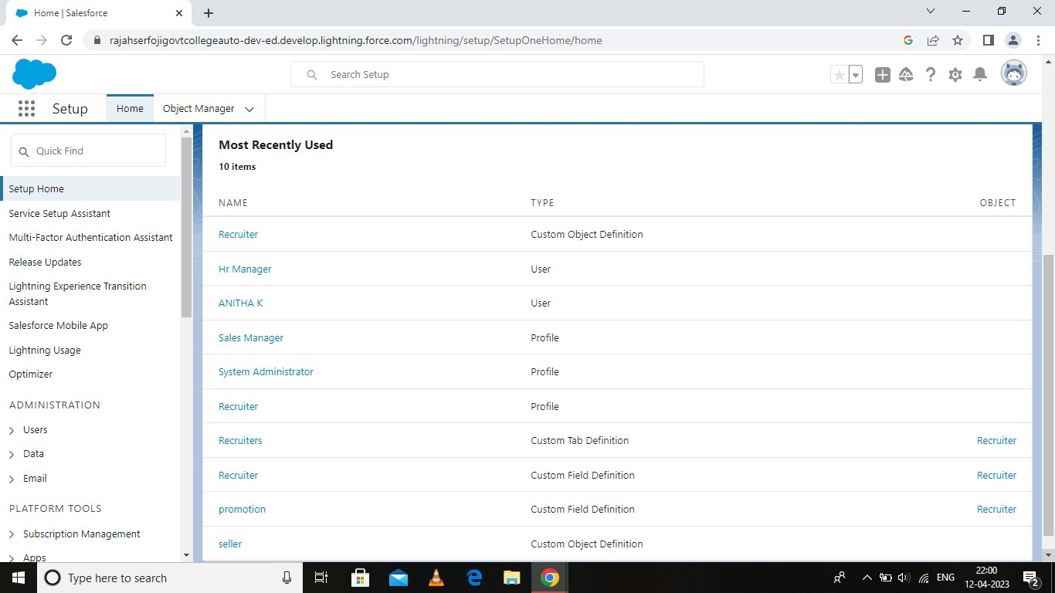

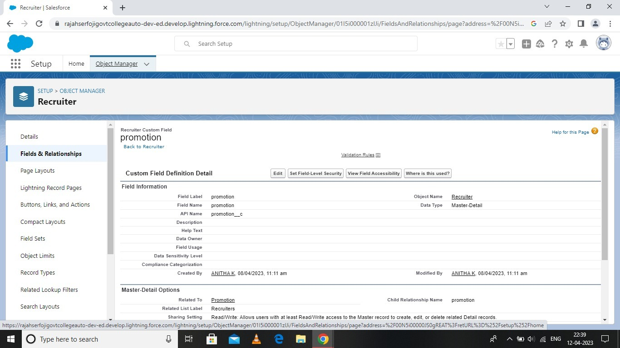

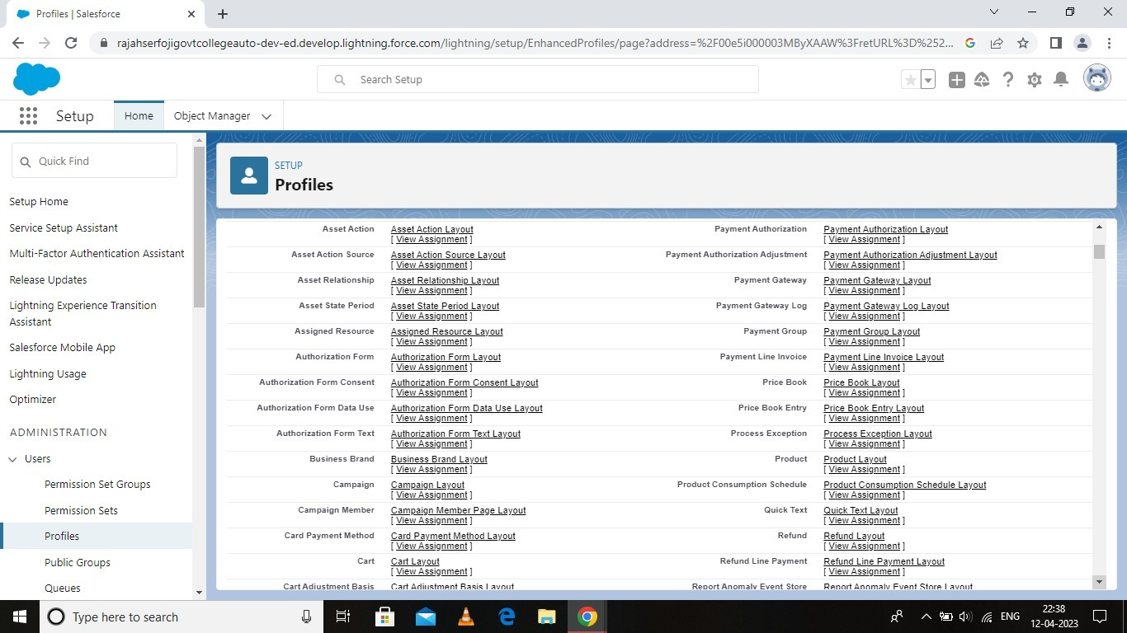

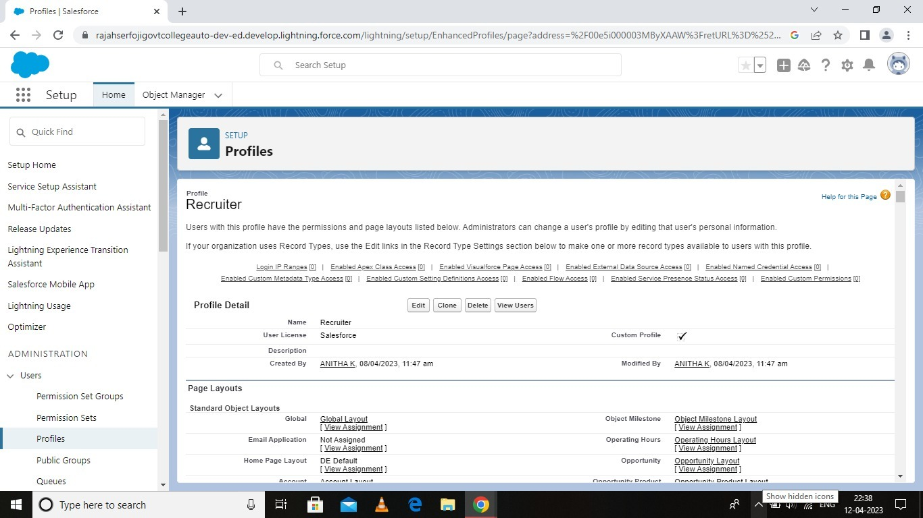

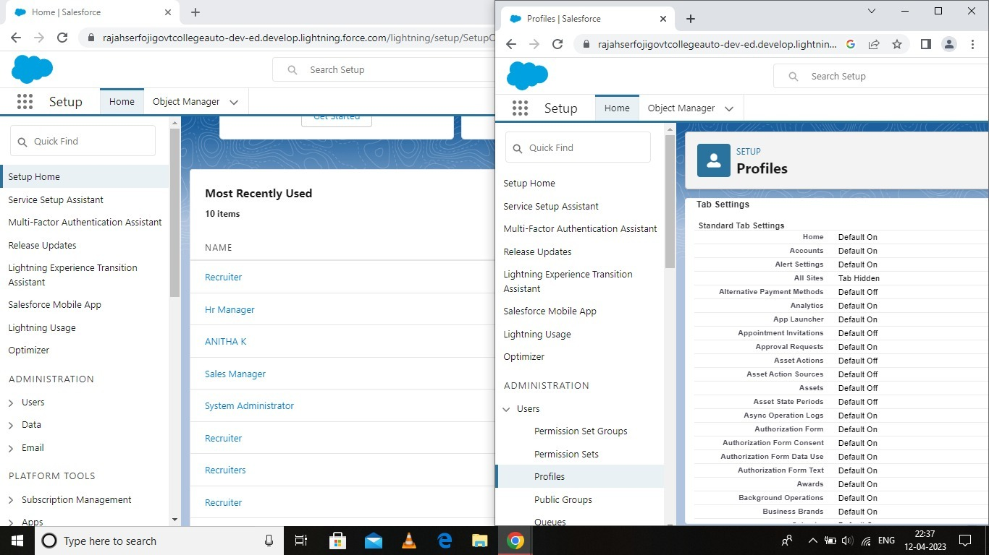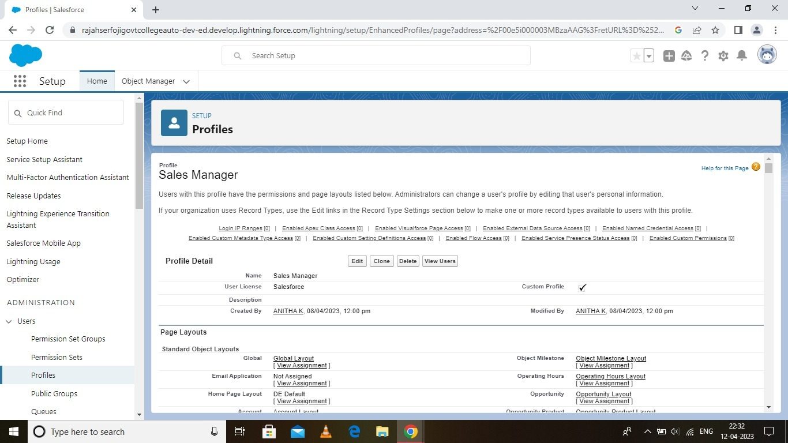

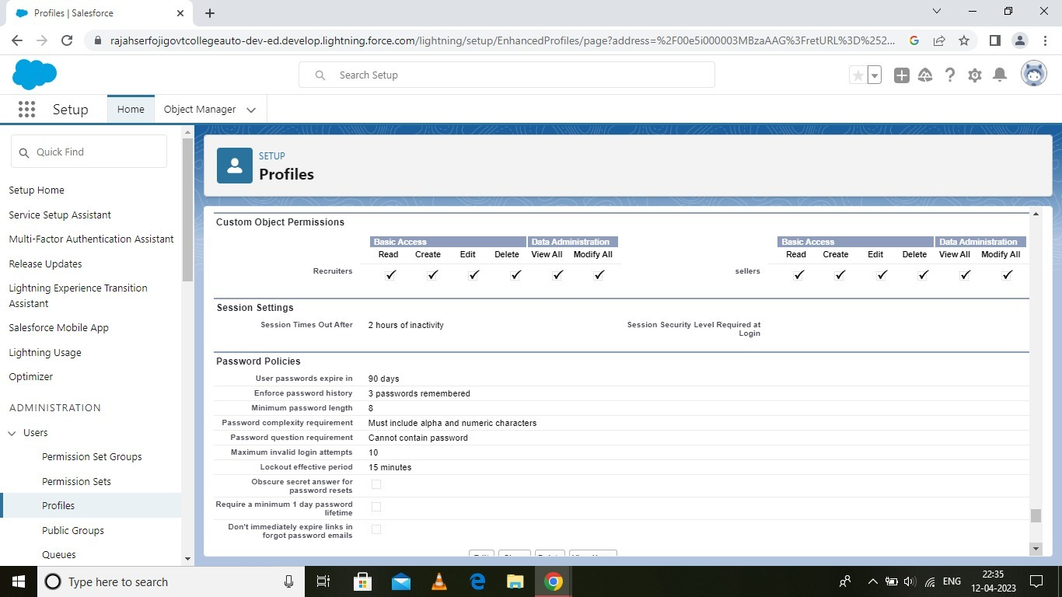

**4. Trailhead Profile Public URL**

Team Lead - K . PRAVEEN KUMAR – H - <https://trailblazer.me/id/pravk45>

Team Member 1 -THIRUGNANAM .K- <https://trailblazer.me/id/thirk12>

Team Member 2 –ANITHA. K - <https://trailblazer.me/id/anitk28>

Team Member 3 –PAVARNA. G- <https://trailblazer.me/id/pavag18>

**5. ADVANTAGES & DISADVANTAGE**

**Advantages:**

* Streamline hiring process
* Affordable
* Conserve time reduce drop off
* Avoid interview blunders
* Improving employee retention

**Disadvantages:**

*Resume pattern were entirely different for different candidates. So all data’s cannot be read by software.

*With handling recruitment, valuable time is wasted in screening irrelevant applicants

**6. APPLICATIONS**

* GPS tracking
* Person tracking
* Yard management
* Fleet management
* Real – time location system. (RTLS)

**7. CONCLUSION**

I have felt that the project based on experimental learning program.

**8. FUTURE SCOPE**

An ATS creates opportunities to automate manual processes, increase visibility into the hiring cycle for the entire recruiting team, and increase opportunities for communication throughout the candidate journey. 78% of recruiters using an ATS report that it has improved the quality of the candidates they hire.